**Kubeflow:**

**Kubeflow is an open-source platform for machine learning and MLOps on Kubernetes** introduced by Google.

The different stages in a typical machine learning lifecycle are represented with different software components in Kubeflow, including **model development, model training, model serving, and automated machine learning**

[**https://www.analyticsvidhya.com/blog/2022/02/workflow-of-mlops-part-2-model-building/**](https://www.analyticsvidhya.com/blog/2022/02/workflow-of-mlops-part-2-model-building/)

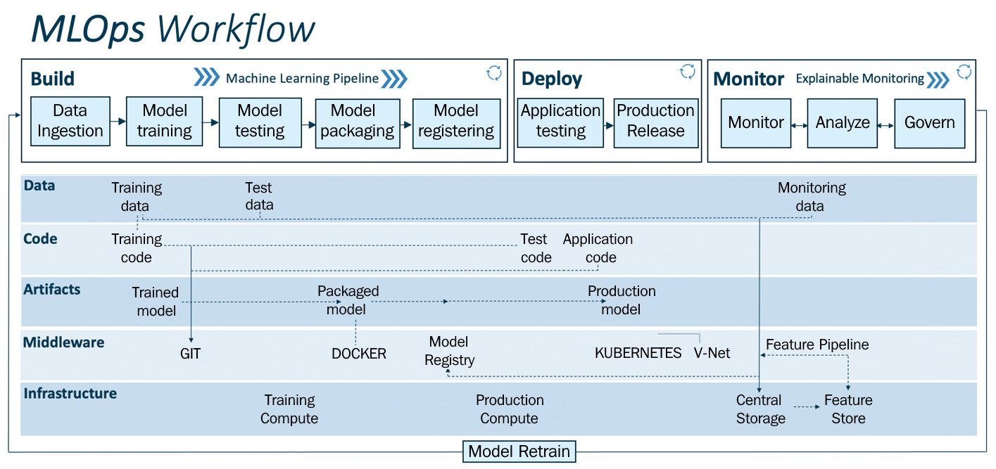

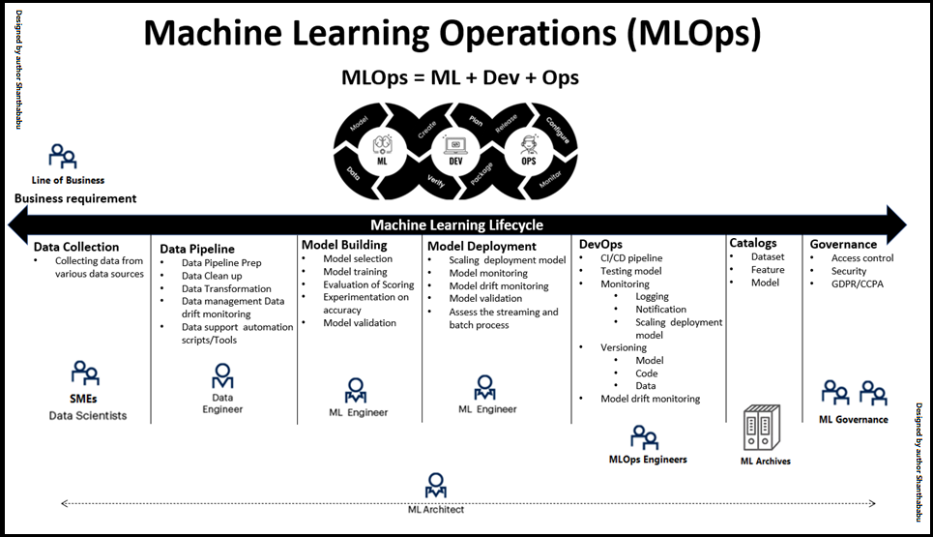

**Azure Pipelines(**[**https://learn.microsoft.com/en-us/azure/devops/pipelines/get-started/what-is-azure-pipelines?view=azure-devops#continuous-integration**](https://learn.microsoft.com/en-us/azure/devops/pipelines/get-started/what-is-azure-pipelines?view=azure-devops#continuous-integration)**)**

[**https://www.analyticsvidhya.com/blog/2022/10/mlops-part-3-model-deployment-and-model-monitoring/**](https://www.analyticsvidhya.com/blog/2022/10/mlops-part-3-model-deployment-and-model-monitoring/)

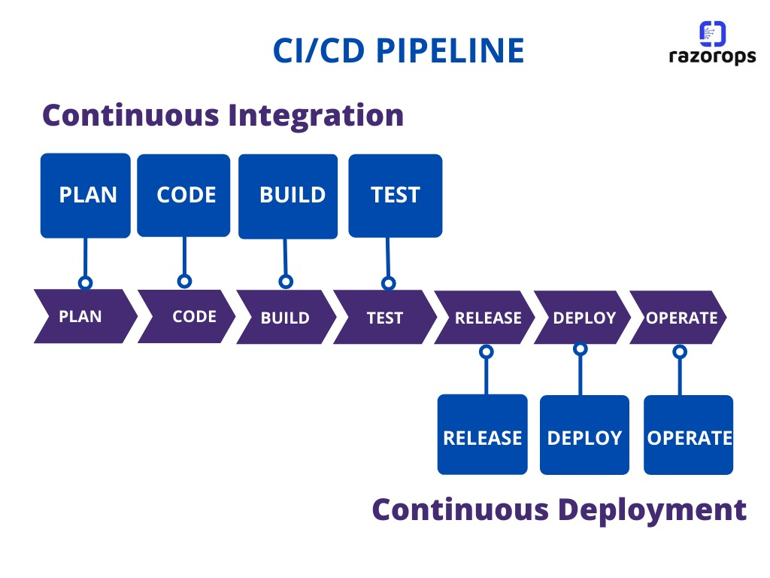

**Continuous Integration**

**Continuous Integration (CI) is the practice used by development teams of automating, merging, and testing code. CI helps to catch bugs early in the development cycle, which makes them less expensive to fix. Automated tests execute as part of the CI process to ensure quality. CI systems produce artifacts and feed them to release processes to drive frequent deployments.**

**Continuous Delivery**

**Continuous Delivery (CD) is a process by which code is built, tested, and deployed to one or more test and production environments. Deploying and testing in multiple environments increases quality. CD systems produce deployable artifacts, including infrastructure and apps. Automated release processes consume these artifacts to release new versions and fixes to existing systems. Systems that monitor and send alerts run continually to drive visibility into the entire CD process.**

**Continuous Testing**

**Whether your app is on-premises or in the cloud, you can automate build-deploy-test workflows and choose the technologies and frameworks. Then, you can**[**test your changes continuously**](https://learn.microsoft.com/en-us/azure/devops/pipelines/ecosystems/dotnet-core?view=azure-devops#run-your-tests)**in a fast, scalable, and efficient manner. Continuous testing offers the following benefits.**

* **Maintain quality and find problems as you develop. Continuous testing with Azure DevOps Server ensures your app still works after every check-in and build, enabling you to find problems earlier by running tests automatically with each build.**
* **Use any test type and any test framework. Choose your preferred test technologies and frameworks.**
* **View rich analytics and reporting. When your build is done, review your test results to resolve any issues. Actionable build-on-build reports let you instantly see if your builds are getting healthier. But it's not just about speed - detailed and customizable test results measure the quality of your app.**

**Continuous Monitoring (CM)**

**Version control systems**

**Azure Pipelines requires your source code to be in a version control system. Azure DevOps supports two forms of version control -**[**Git**](https://learn.microsoft.com/en-us/azure/devops/repos/get-started/what-is-repos?view=azure-devops)**and**[**Azure Repos**](https://learn.microsoft.com/en-us/azure/devops/repos/get-started/what-is-repos?view=azure-devops)**. Any changes you push to your version control repository are automatically built and validated.**

**Languages and applications**

**You can build, test, and deploy Node.js, Python, Java, PHP, Ruby, C#, C++, Go, XCode, .NET, Android, and iOS applications. Run these apps in parallel on Linux, macOS, and Windows.**

**Azure DevOps offers tasks to build and test .NET, Java, Node, Android, Xcode, and C++ applications. Similarly, there are tasks to run tests using many testing frameworks and services. You can also run command line, PowerShell, or Shell scripts in your automation.**

**Deployment targets**

**Use Azure Pipelines to deploy your code to multiple targets. Targets include virtual machines, environments, containers, on-premises and cloud platforms, or PaaS services. You can also publish your mobile application to a store.**

**Once you have continuous integration in place, create a release definition to automate the deployment of your application to one or more environments. This automation process is defined as a collection of tasks.**

**Model Drift (Drift means FLOW)**

**Sometimes, our model may not perform well after a few days, weeks, or years. This happens because of the change in the properties of the dependent(target) variable. This change can make our model useless. So this change is called** **Model Drift. We have to analyze the failed results to get the new properties of the target variable.**

**Concept Drift** – **if something causes or it so happens the relation from XàY (in between dependent and independent variables) changes during the deployment, it would lead to concept drift. For example, during the coronavirus time, a lot of fraud detection systems started to** fail and not **perform because a huge segment of the population suddenly moved to online transactions for which these systems were not designed and they started mistaking them as fraud whereas they were genuine transactions because people were shopping online due to the lockdowns.**

**Data Drift** – **It happens when the range of one or more X (independent) variables shifts compared to the modelling set. For Eg, if an image processing model were trained only in bright lighting conditions, it would not function well in a dark or dimly let condition.**

**Microsoft Azure MLOps Suite:**

[Microsoft Machine Learning](https://azure.microsoft.com/en-us/services/machine-learning/) – Build, train, evaluate models

[Azure Pipeline](https://azure.microsoft.com/en-us/services/devops/pipelines/) – Automate ML

[Azure Monitor](https://docs.microsoft.com/en-us/azure/azure-monitor/overview) – Tracking and monitoring

[Azure Kubernetes Service](https://azure.microsoft.com/en-us/services/kubernetes-service/) – Managing containers

**Google Cloud MLOps:**

[Dataflow](https://cloud.google.com/dataflow) – Used for ETL

[BigQuery](https://cloud.google.com/bigquery) – Cloud data warehouse, which is used as the source for ML training

[TFX](https://www.tensorflow.org/tfx) – to deploy models

**WaterFall:**

[**https://editor.analyticsvidhya.com/uploads/51579jira-waterfall-model.png**](https://editor.analyticsvidhya.com/uploads/51579jira-waterfall-model.png)

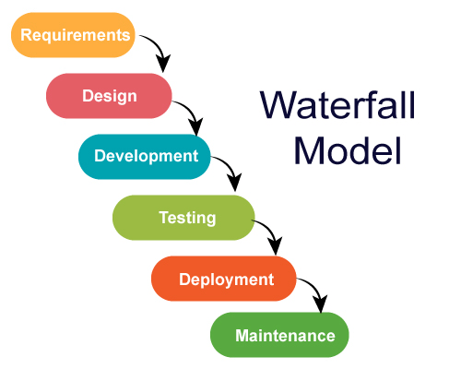

**Agile Methodology**

